
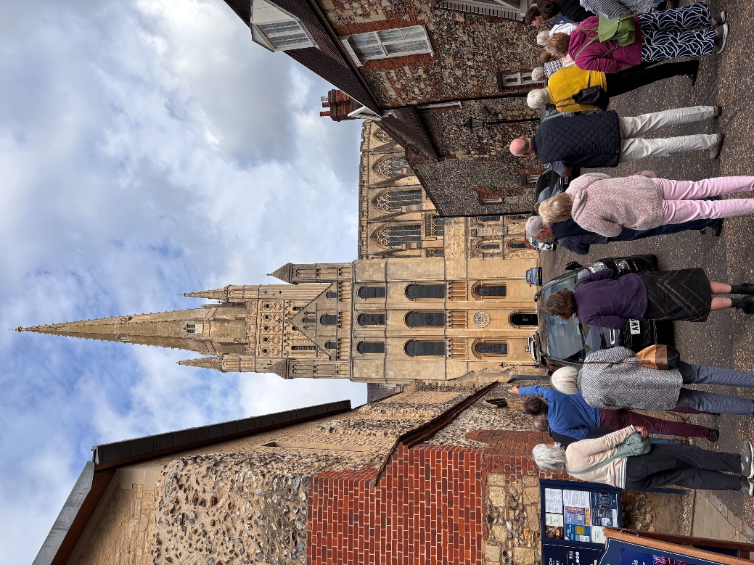
Newsletter October 2026
Dear Friends,
What would a world without forgiveness look like? Be like? Let's imagine for a few moments what it would be like to live in such a world. An unforgiving world is not God like. There would be many angry moments, some potentially violent. It would foster dishonesty and lying. It would lead to putting up dividing walls between people which are permanent. The wonder of forgiveness is that it opens doors to healing and reconciliation. It's not that those who choose to forgive forget, but they choose not to yield to the same destructive forces of revenge and retribution. God's forgiveness surpasses both our deserving and comprehension of it, and therefore the appropriate response is always to forgive, because God always forgives us everything. Of course, forgiveness doesn't mean that we stand by while evil things happen. If we become aware of a serious and ongoing crime or situation like domestic abuse or human trafficking or domestic slavery, then we have to act and inform the authorities. Forgiveness is balanced with our duty to protect the vulnerable from bad people. Keeping people safe and being a safe space as a church community for everyone is fundamental to our Christian calling and way of life. We must always call out wrongdoing and take appropriate action when we witness or learn about something that is seriously wrong. When Jesus commands us to forgive he is not talking about ignoring evil or wrongdoing. Jesus stood up for the vulnerable and oppressed and called out evil for what it was. Jesus was a big champion for fighting evil. He didn't tolerate it. Yet he was a proponent of forgiveness and turning the other cheek, not least on the cross. He is talking about a frame of mind or an attitude where we don't carry grudges. Where we try and give others another chance. Where we love them enough to forgive. Ultimately, Jesus teaches us that God will judge all things and all people in the end. By forgiving and not carrying grudges and anger, we can feel God's peace because we are freed while they're imprisoned by the things done to us. When we choose to forgive, then we are choosing Jesus's way, the way of love, which can completely transform us and our lives.
God Bless,
Clare
Revd Clare Coates
Team Rector of the Lordsbridge Team
Lead Minister for Hardwick, Dry Drayton and Caldecote with Childerley
clarecoates@lordsbridge.org
07818 618795
October Services
Sunday 4 October
9:30am Holy Communion with Revd Clare
Sunday 11 October
9:30am Harvest Festival with Ali Marcus and Revd Clare.
As part of our Harvest celebrations this year, we’re supporting Cambridge City Foodbank, who provide emergency food and wider support across our city, to people struggling to afford the essentials.
From today, we’ve set up a Harvest Food Collection Point either at the Cabin in Harwick or in Dry Drayton Church where you can drop off non-perishable food donations. We’ll be collecting until Sunday 11th October, so please do consider bringing one or more items of food to church before then.
You can also donate online:
https://cambridgecity.foodbank.org.uk/support-us/donate-money
Let’s come together as a church community to share God’s love in a practical way.
There will be an auction of fresh foods after the service in the Cabin.
Sunday 18 October
9:30am Morning Worship with Michaela McNeill and Peter Cornwell
Sunday 25 October
10:30am Holy Communion Team service at St Peter and St Paul’s Dry Drayton with Revd Clare
Weekday Services:
Wednesday Prayers
1st Wednesday of the month, 9am at the Cabin
And in the following weeks, on zoom. All welcome. Please ask Revd Clare for more details.
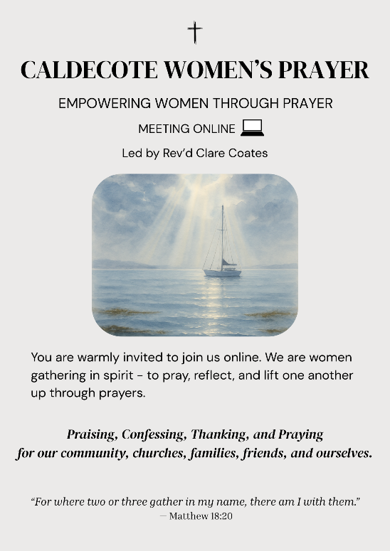
Caldecote Women’s Prayer group Thursday mornings in term time at 9am on Zoom Women from Caldecote and surrounding villages are warmly invited to join us online, gathering in spirit to pray, reflect and lift one another up through prayers. https://us02web.zoom.us/j/88137270141?pwd=pCvjk7eQrFqYX8GrvRP6JmMZKI9bYK.1
Meeting ID: 881 3727 0141
Passcode: 655934
Friday night prayers at 7:30pm, on Zoom
All most welcome to join us on Fridays for night prayers starting at 7.30 pm with chat and prayer actually beginning at 7.45 pm: https://us02web.zoom.us/j/83806423658?pwd=Ux2yZaz0VJeLnNbF12pUyuvihUeSkL.1
Meeting ID: 838 0642 3658
Passcode: 167011
What’s on:
Saturday 10 October Harvest Supper and Ceilidh
From 7pm at the school. Ask Sue Cornwell for more details and to buy your tickets!
Saturday 17 October
The Big Book sale at the Cabin 10-4pm! Lots of great books to choose from and refreshments served all day.
Sunday 18 October at St Peter and St Paul’s Dry Drayton

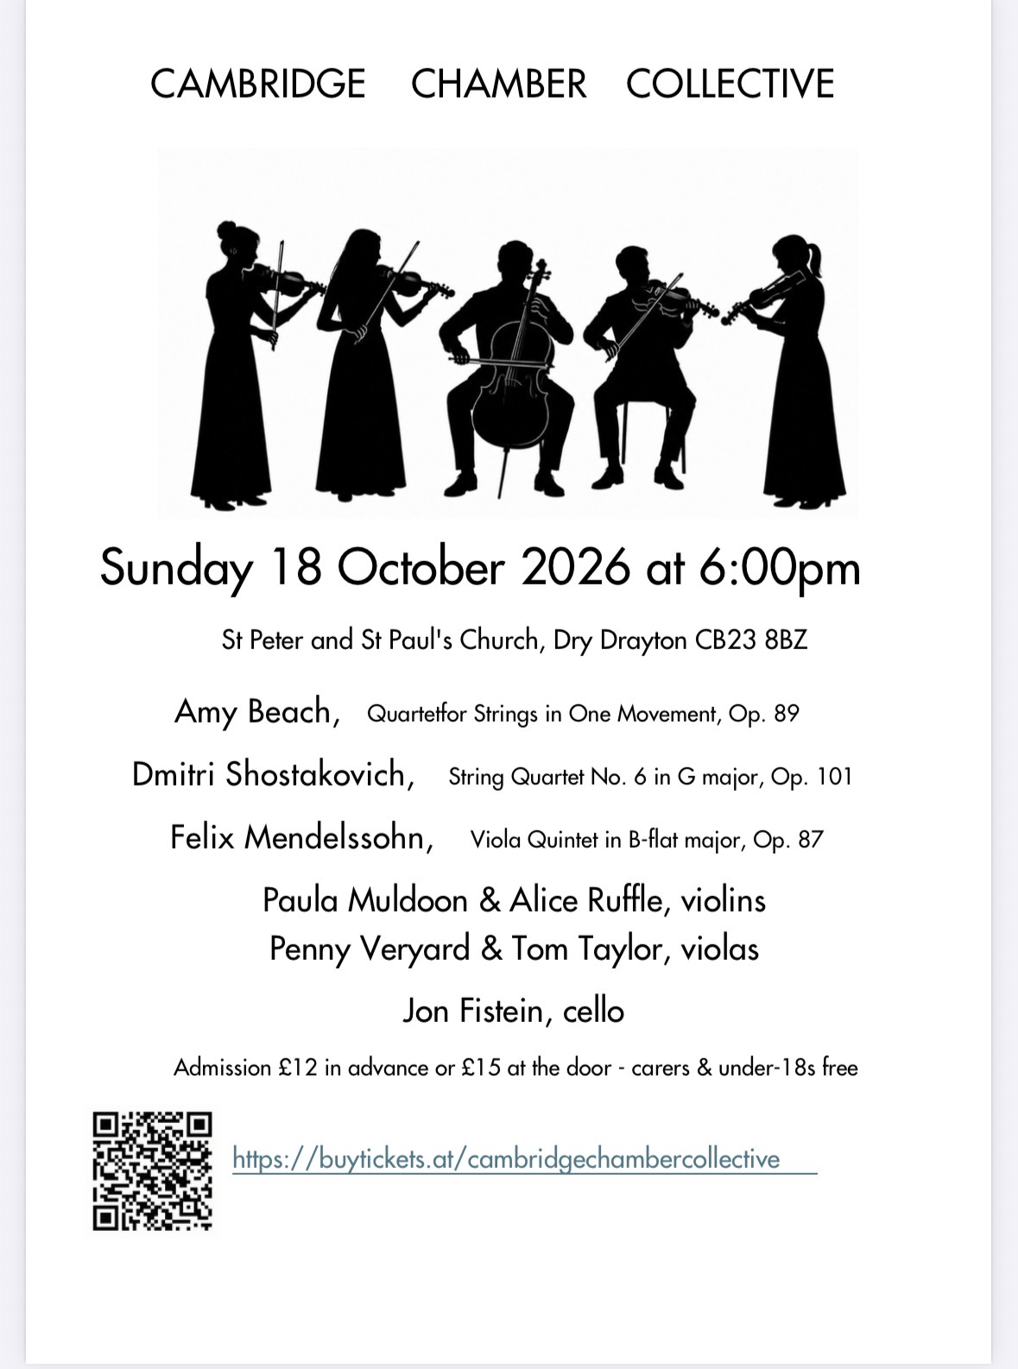
Saturday 24 October 10-12 at the Cabin in Hardwick: Rooted: Discovering Ways to pray with Revd Clare Coates and Revd Steve Clark
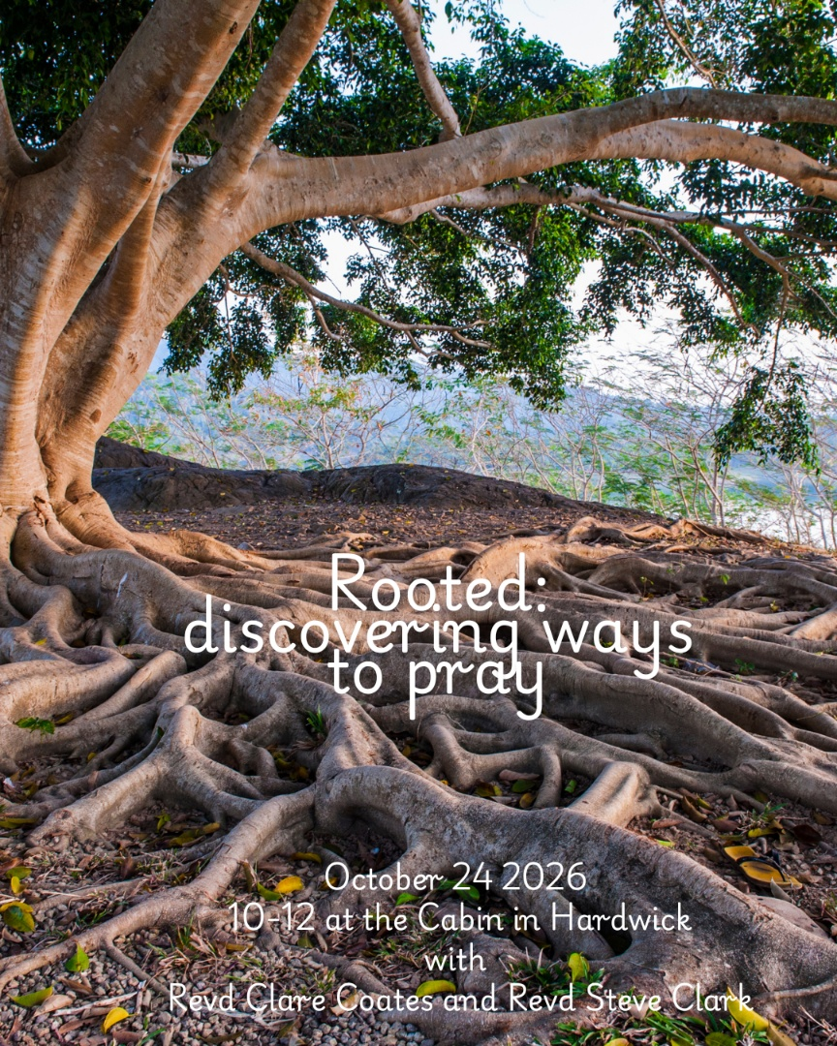
Are you a regular intercessor at your Church? Or would you like to try leading prayers? Would you like to find out more about prayer, and why we pray?
Prayer is at the heart of our lives and work as Christians and as a Team. We believe God is calling us to a deeper commitment to prayer and we are expectant that God is at work in us as we seek Him together. We believe that prayer is more than something we ‘do.’ Let’s plant firm roots in God as we pray together and as we seek to draw closer to Him together.
All are very welcome to join us for a morning workshop, focusing on discovering the many different ways we can pray, and finding your own voice as you pray.

Community
Tuesday Toddlers in the Cabin 10-11:30am, every Tuesday in term time.
All welcome to join us for free play, craft, story and fun!
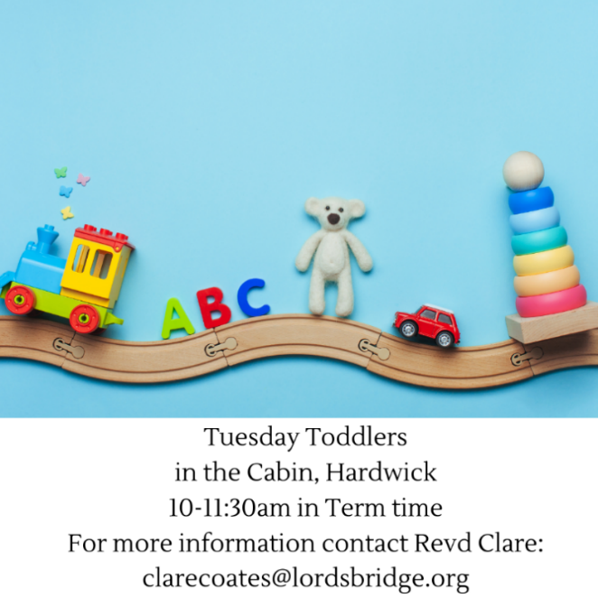
.

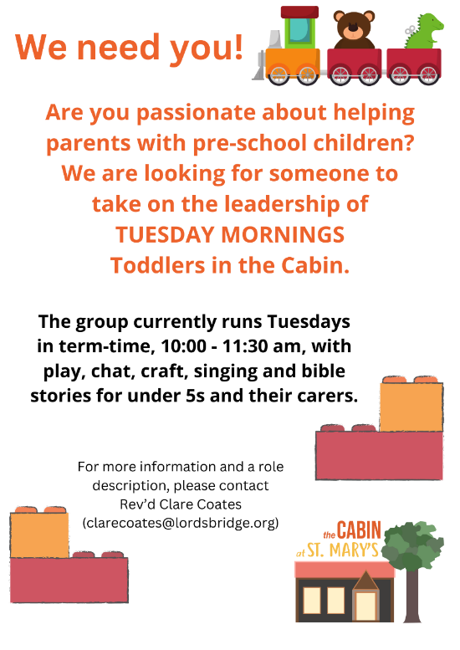


Tuesdays, alternate weeks:
1-3pm The Colour Wheel Hardwick Mindful Colouring Group:
in the Cabin. £3 donation which includes refreshments and materials. For more information contact Nicky 07539 429394 kerranica@gmail.com
Thursdays
10:30 – 12: Bumps and Babes with Ali in the Cabin. All welcome.

1st Saturday of every month: Pippins
10am-12 noon, in Hardwick School Hall. Drop in for a cuppa, cake and a chat! All most welcome.

Useful contacts
Revd Claire Robertson, Lead Minister for Coton, Barton, Harlton and Haslingfield: 01223 874194; clairerobertson@lordsbridge.org
Revd Charles Fraser, Lead Minister for Little and Great Eversden: charlesfraser@lordsbridge.org; 01223 264974
Team Administrator: Mrs Sue Squire: thelordsbridgeteam@gmail.com
Lordsbridge Team Instagram: @lordsbridge_team
Lordsbridge Team Facebook Page: https://www.facebook.com/LordsbridgeTeam

