
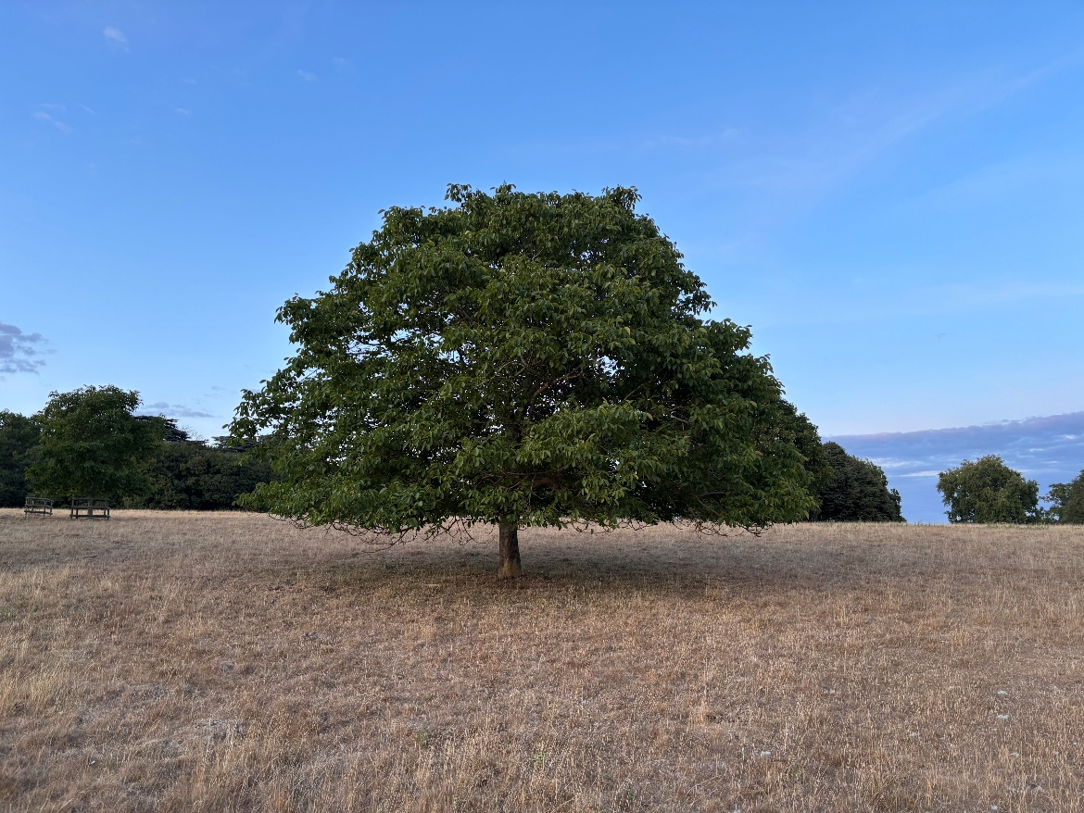

Newsletter September 2026
Dear Friends,
We have recently been reflecting on some of Jesus’s most challenging teaching during our Sunday morning services, including the passage where Jesus uses an analogy about throwing scraps to dogs when he encounters a desperate Canaanite mother who had come to him for help. She crossed cultural boundaries, endured public humiliation and accepted being compared to a dog in order to save her child. Jesus was uncharacteristically dismissive of her and used these seemingly harsh words to send her away: It's not fair to take the children's food and throw it to the dogs. (v26) And yet the woman shows incredible inner strength as she knelt before Jesus and said: Lord, help me. (v25)
The mother was desperate for help and broke all the rules to get that help. Not only approaching a man from a different faith and interrupting him as he was with his friends but also arguing with him. Openly and boldly. Despite the possibility of rejection, ridicule and humiliation. She shows great faith because she sees and understands Jesus is the only one who can help her. Only Jesus is able to save her child. Her faith in him never wavered. She believed Jesus would help and trusted that he would act. It's human nature to think we can do everything on our own steam. But the woman's example illustrates the importance for us to acknowledge we need Jesus. We can't do everything in our own strength. Jesus is the only one who can give us true peace and joy.
This short story is ultimately about a very brave and desperate mother doing the best for her child. She wouldn't take no for an answer. Jesus recognised this. He listened to her and he changed his mind, responding to her persistence and love with his own. This story shows us: God hears us. God listens. And God acts out of love. So, let's be greatly encouraged today. Do not be afraid to ask Jesus for help. And to continue asking. Because he promises to listen and answer when we ask him.
God Bless,
Clare
Revd Clare Coates
Team Rector of the Lordsbridge Team
Lead Minister for Hardwick, Dry Drayton and Caldecote with Childerley
clarecoates@lordsbridge.org
07818 618795

September Services
Sunday 6 September
9:30am Holy Communion with Revd Clare
Sunday 13 September
9:30am Baptism service with Ali Marcus and Revd Clare
3pm Wild Church
Sunday 20 September
9:30am Holy Communion with Revd Clare
Sunday 27 September HARDWICK AWAY DAY to NORWICH CATHEDRAL
Or 10:30am West Cambridge Churches Joint Service at Comberton Leisure Centre
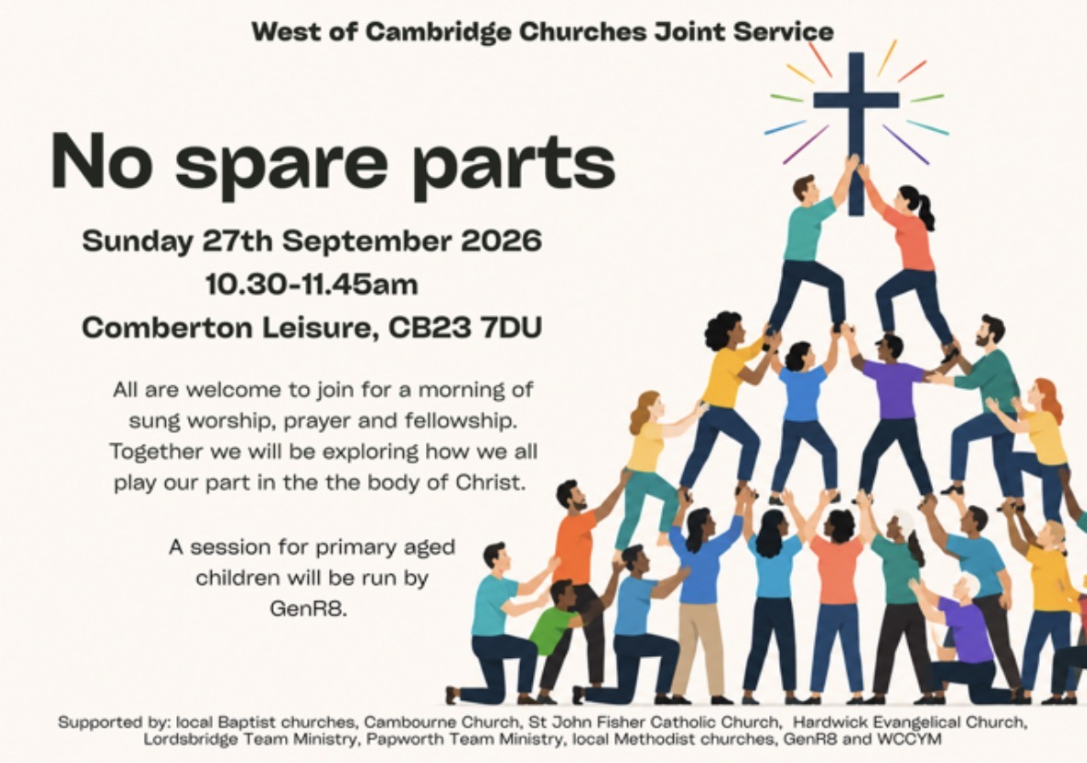
What’s on
Weekday Services:
Wednesday Prayers
1st Wednesday of the month, 9am at the Cabin
And in the following weeks, on zoom. All welcome. Please ask Revd Clare for more details.
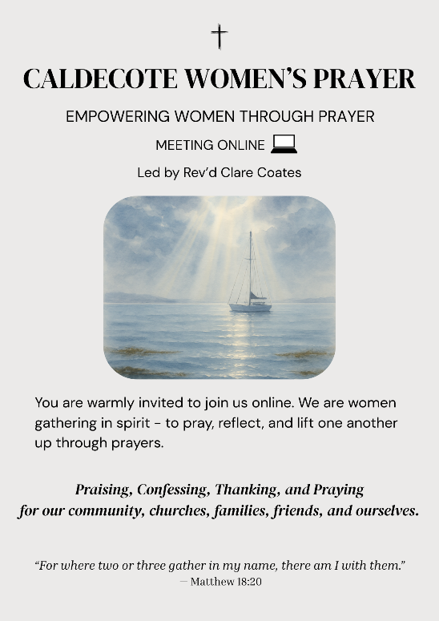
Caldecote Women’s Prayer group Thursday mornings in term time at 9am on Zoom Women from Caldecote and surrounding villages are warmly invited to join us online, gathering in spirit to pray, reflect and lift one another up through prayers. https://us02web.zoom.us/j/88137270141?pwd=pCvjk7eQrFqYX8GrvRP6JmMZKI9bYK.1
Meeting ID: 881 3727 0141
Passcode: 655934
Friday night prayers at 7:30pm, on Zoom
All most welcome to join us on Fridays for night prayers starting at 7.30 pm with chat and prayer actually beginning at 7.45 pm: https://us02web.zoom.us/j/83806423658?pwd=Ux2yZaz0VJeLnNbF12pUyuvihUeSkL.1
Meeting ID: 838 0642 3658
Passcode: 167011

Community
Tuesday Toddlers in the Cabin 10-11:30am, every Tuesday in term time. Back from 8 September!
All welcome to join us for free play, craft, story and fun!
.

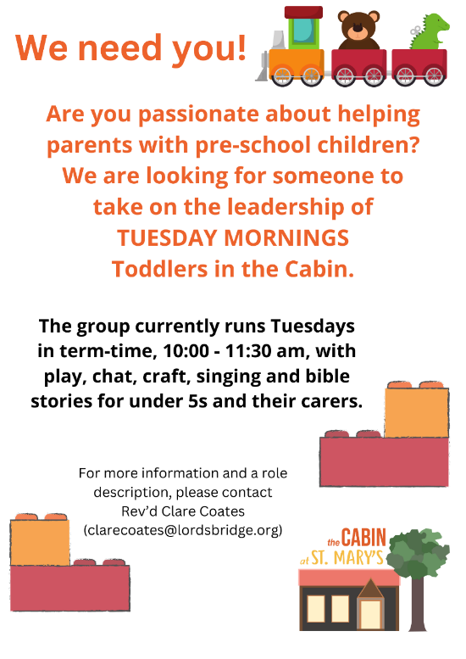


Tuesdays, alternate weeks:
1-3pm The Colour Wheel Hardwick Mindful Colouring Group:
in the Cabin. £3 donation which includes refreshments and materials. For more information contact Nicky 07539 429394 kerranica@gmail.com
Thursdays
10:30 – 12: Bumps and Babes with Ali in the Cabin. All welcome.

1st Saturday of every month: Pippins
10am-12 noon, in Hardwick School Hall. Drop in for a cuppa, cake and a chat! All most welcome.

Useful contacts
Revd Claire Robertson, Lead Minister for Coton, Barton, Harlton and Haslingfield: 01223 874194; clairerobertson@lordsbridge.org
Revd Charles Fraser, Lead Minister for Little and Great Eversden: charlesfraser@lordsbridge.org; 01223 264974
Team Administrator: Mrs Sue Squire: thelordsbridgeteam@gmail.com
Lordsbridge Team Instagram: @lordsbridge_team
Lordsbridge Team Facebook Page: https://www.facebook.com/LordsbridgeTeam

