
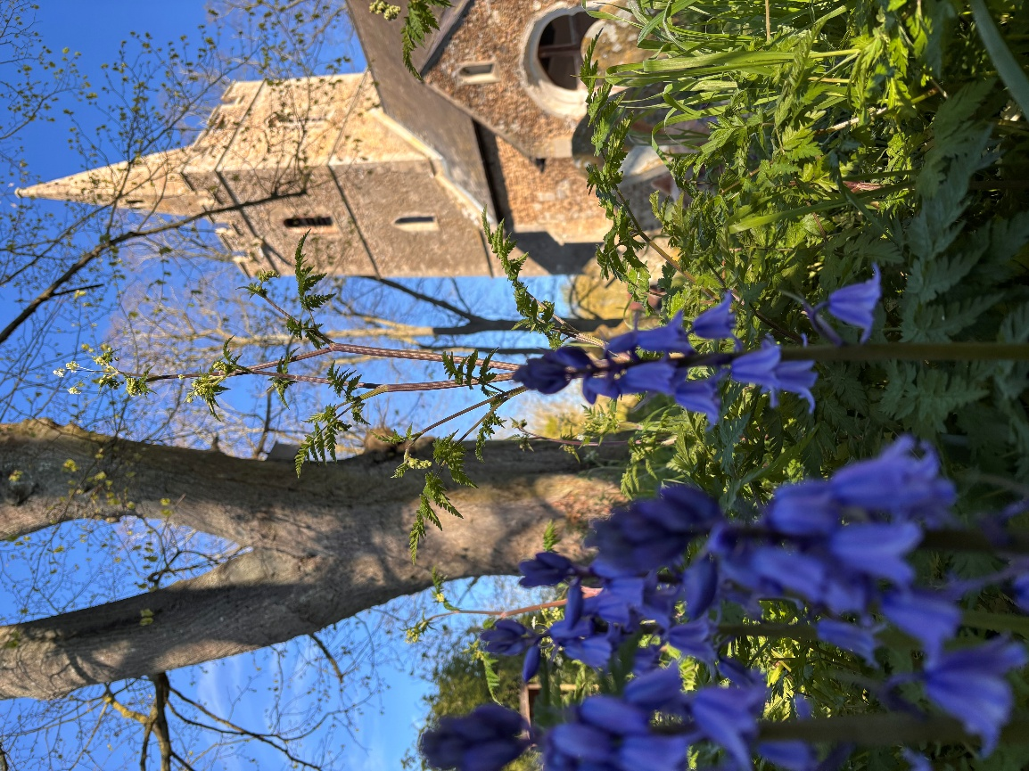

Newsletter May 2026
Dear Friends,
There is something incredibly spiritual about walking with friends – and making new ones along the way. Later in the month we will be embarking on our annual Lordsbridge Pilgrimage once more on Friday 22 May. This year we are trying something different. The walk has two routes – Northern (starting in Barton at 7:30am) and Southern (starting at 9:30am). Please see the poster below for more details. I will be joining the Northern route which crosses through Coton, Hardwick, Caldecote and Childerley before finishing in Dry Drayton. I am very much looking forward to visiting all these churches again, and to chatting with my fellow pilgrims enroute. Please do join us if you can, even if it’s just for a short stretch, or to welcome us home to Dry Drayton, where the Pilgrimage ends with lunch at approximately 2pm.
For Christians, going on pilgrimage involves a search for a deeper spirituality and for a closer connection to God. For the first time in modern history, our new Archbishop of Canterbury, Archbishop Sarah, completed an historic pilgrimage starting at St Paul’s Cathedral in London and walking 140km in 6 days to Canterbury. It was incredible to see so many people walking with her, greeting and meeting her enroute. Upon reaching Canterbury, Archbishop Sarah said: “It’s been a real joy; it’s also a joy to know we are done!” Pilgrimages are a great adventure, with the chance to meet new people and to see new places. To set aside time for God and feel closer to Him; to discern His will and guidance; and to be strengthened in faith. Going on pilgrimage can give us a new sense of awareness and wonder. Or result in a greater sense of our life’s purpose. Pilgrimage helps us to focus on ‘what really matters’ and to rediscover the joy of giving and generosity. I look forward to seeing you along the way!
God Bless,
Clare
Revd Clare Coates
Team Rector of the Lordsbridge Team
Lead Minister for Hardwick, Dry Drayton and Caldecote with Childerley
clarecoates@lordsbridge.org
07818 618795

Services in May 2026
Sunday 3 May
9:30am Holy Communion with Revd Clare.
Sunday 10 May
9:30am Morning Worship for all ages with Ali Marcus
3-4pm Wild Church
Thursday 14 May Ascension Day
7 pm Lordsbridge Team Service at Harlton Church with Revd Clare and Sue Nelms preaching
Sunday 17 May
9:30am Holy Communion with Revd Clare
Sunday 24 May
9:30am Holy Communion with Revd Clare.
Sunday 31 May
10:30am Lordsbridge Team Fifth Sunday service church at Great Eversden Church with Revd Claire and Revd Clare preaching
Weekday Services:
Wednesday Prayers
1st Wednesday of the month, 9am at the Cabin
And in the following weeks, on zoom. All welcome. Please ask Revd Clare for more details.
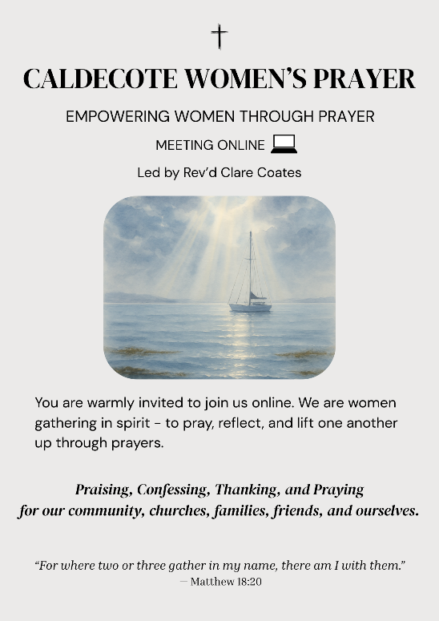
Caldecote Women’s Prayer group Thursday mornings in term time at 9am on Zoom Women from Caldecote and surrounding villages are warmly invited to join us online, gathering in spirit to pray, reflect and lift one another up through prayers. https://us02web.zoom.us/j/88137270141?pwd=pCvjk7eQrFqYX8GrvRP6JmMZKI9bYK.1
Meeting ID: 881 3727 0141
Passcode: 655934

Friday night prayers at 7:30pm, on Zoom
All most welcome to join us on Fridays for night prayers starting at 7.30 pm with chat and prayer actually beginning at 7.45 pm: https://us02web.zoom.us/j/83806423658?pwd=Ux2yZaz0VJeLnNbF12pUyuvihUeSkL.1
Meeting ID: 838 0642 3658
Passcode: 167011

SAVE THE DATE!
Friday 1 May Quiz at the School 7:30pm
Please contact Anne Jones for more details.
Saturday 16 May Church Fete 12- 4pm in the Cabin grounds
Please contact Sue Cornwell for more details.
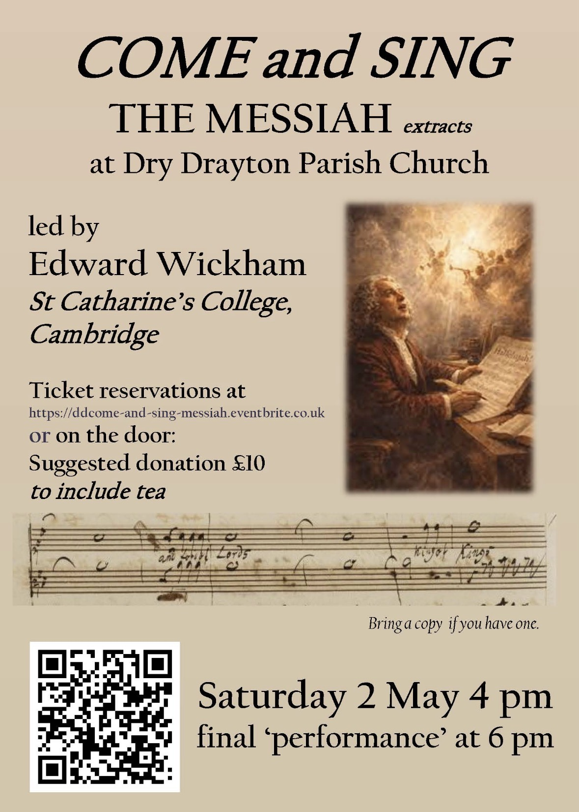



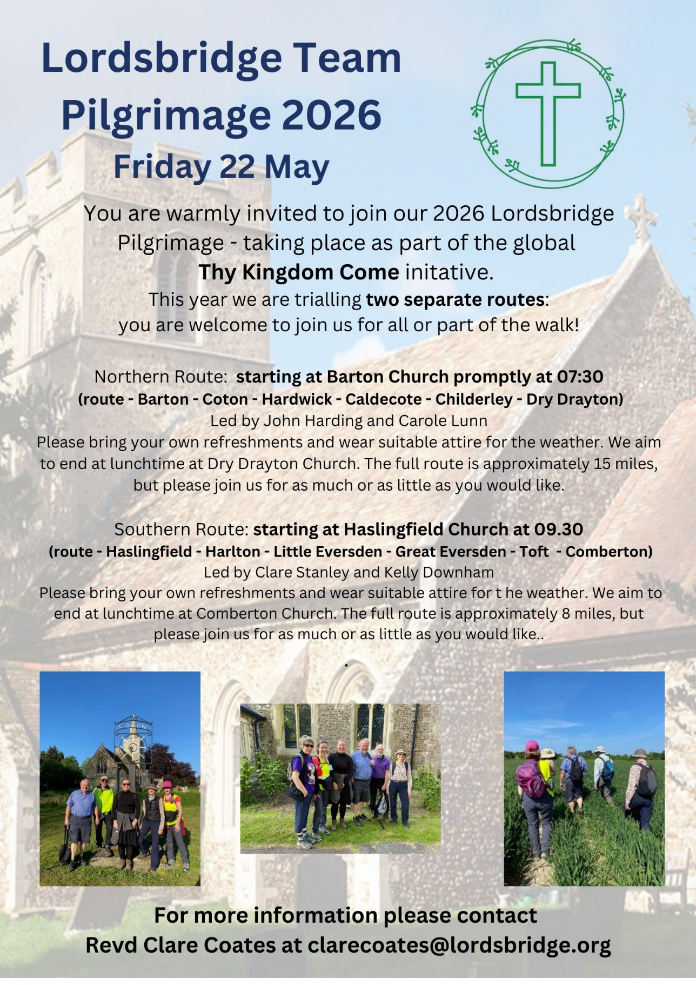
The Northern route:

Barton (leaving) 7:30am

Coton (leaving) 8:45am

Hardwick (leaving) 10am

Caldecote (leaving) 11:30am

Childerley (leaving) 1pm

Dry Drayton (arriving - for lunch!) c. 1:45pm

The Southern route:

Haslingfield (leaving) 9:30am

Harlton (leaving) 10:15am

Little Eversden (leaving) 11:am

Great Eversden (leaving) 11:30am

Toft (leaving) 12:30 pm

Comberton (arriving - for lunch!) c1:15pm


What's on:
Tuesday Toddlers in the Cabin 10-11:30am, every Tuesday in term time.
All welcome to join us for free play, craft, story and fun!
.

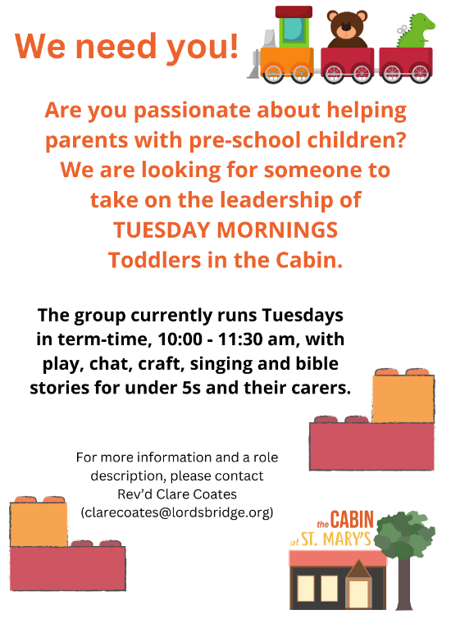

Tuesdays, alternate weeks:

1-3pm The Colour Wheel Hardwick Mindful Colouring Group:
in the Cabin. £3 donation which includes refreshments and materials. For more information contact Nicky 07539 429394 kerranica@gmail.com
Thursdays
10:30 – 12: Bumps and Babes with Ali in the Cabin. All welcome.
1st Saturday of every month: Pippins
10am-12 noon, in Hardwick School Hall. Drop in for a cuppa, cake and a chat! All most welcome.

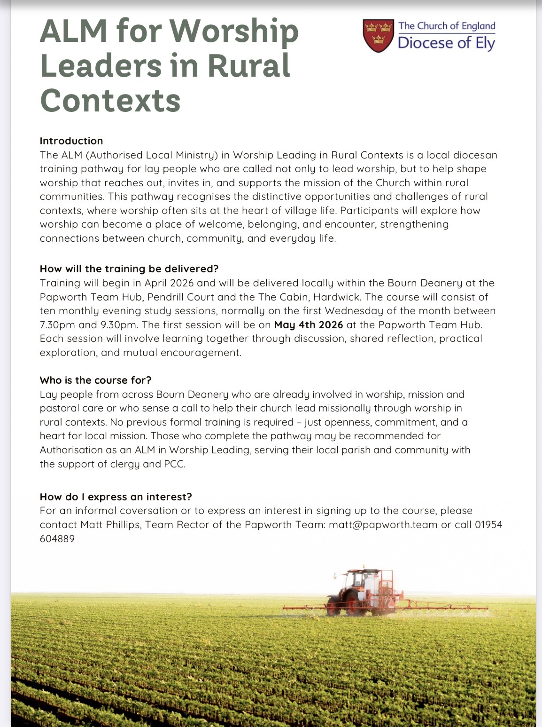Useful contacts
Revd Claire Robertson, Lead Minister for Coton, Barton, Harlton and Haslingfield: 01223 874194; clairerobertson@lordsbridge.org
Revd Charles Fraser, Lead Minister for Little and Great Eversden: charlesfraser@lordsbridge.org; 01223 264974
Team Administrator: Mrs Sue Squire: thelordsbridgeteam@gmail.com
Lordsbridge Team Instagram: @lordsbridge_team
Lordsbridge Team Facebook Page: https://www.facebook.com/LordsbridgeTeam

