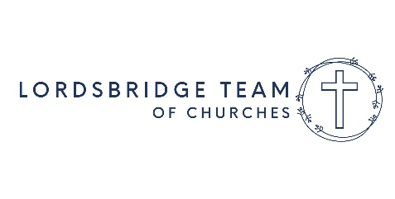
Tenth Sunday after Trinity – 8th Aug 2021
Read John 6.35, 41-51
You may like to use this material as a basis for discussion in your family.
Who would have thought that a young woman could give up her job as a chef in 2017 and then win a Gold medal for Great Britain in the 2021 Olympic Games? That is what happened to Charlotte Worthington who won Gold in the BMX freestyle event last week. She is the first woman to successfully complete a 360 degree backflip in a competition.
I’m sure that many people who knew Charlotte when she was younger would have been surprised and would probably say “No way!”
We sometimes make judgements about other people without really knowing what they are like or what they are capable of. We may make a snap judgement based on their age, their looks, their job, or the way they speak. For example, some people assume that girls are better at ballet than boys, or that old people are boring. Can you think of a time when you made a judgement about someone – only to find out later that you were mistaken? Has anyone every misjudged you?
In today’s Gospel reading Jesus describes himself as the “bread of life” that has come down from heaven. The people who are listening to him cannot accept this. They are very upset, even angry, about what he is saying. They know Jesus as the son of a local carpenter. They know that his parents are Mary and Joseph. How can he say that he has come from heaven? How do you think you would have reacted if you had heard Jesus say this?
We should get to know people well before we make judgements about them. How can we get to know Jesus better so that we can understand who he is?
Activity
- Teach yourself a new physical skill, one you can practice indoors or outdoors like juggling, balancing exercises, a roly-poly! How does it feel to try something new? Was it difficult? Did you have to push through? How did it feel once you’d achieved your goals? What did you find out about yourself?
Prayer
Dear God, we are sorry for the times when we make judgements about others without knowing them well. Forgive us and help us to be loving and generous people. Amen.

