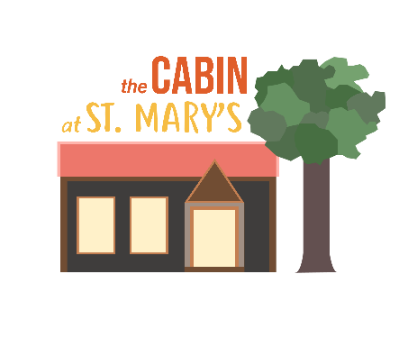

Tuesday Morning Registration Form
Thank you for registering for Tuesday Mornings in advance. It helps us minimise passing paper and pens between people in Covid times, and prepare well.
Date:
Name of responsible adult:
Relationship to children:
Address:
Email:
Phone number:
Names and dates of birth of children:

Would you be interested in joining a Tuesday Morning WhatsApp group? Yes/Not now/No
May we keep your details securely on file so that we can contact you about Wild Church and similar events? Yes/No
May we put you on our Tuesday Morning and Family events mailing lists to let you know about other events suitable for families? Yes/No
We might take photos at Tuesday Mornings for publicity purposes. Do we have your consent to take photos which include members of your children? Yes/No
Our Photography Policy, Data Privacy Notice and Safeguarding Statement are available from our website (or will be shortly). https://stmaryshardwick.org.uk/policies/
Please return the completed form to
Clare Bigg cebigg53@gmail.com 07307 627797

