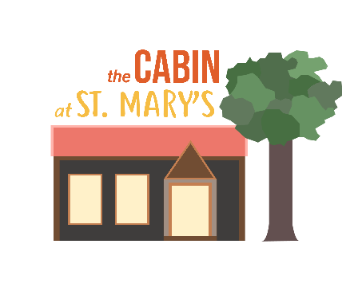
The Cabin at St Mary’s
Appendix 2 – Booking Form for use from 08/08/21
Please complete and return this form to the Bookings Secretary via cabin@stmaryshardwick.org.uk
Name:
Group/organisation:
Address:
Email:
Tel No: Mobile:
Day required:
Date of proposed hiring:
Time required (remember to allow for set-up and pack-down if you need more than 15 minutes).
Activity: From To
If a recurring booking is requested please give details below:
Dates:
Facilities required – Please tick:
Main hall |  | Kitchen for making drinks only |  | Outside area
Meeting room |  | Kitchen for food prep and cooking (extra charge)

Please note that the carpark, garden, toilets and kitchen (for making drinks) may be shared by other users of the building and the church. Please book both the hall and meeting room if you would prefer that another group is not sharing the building. We will inform you if there is a large event happening in the church during your let (eg a funeral) which might impact use of the carpark and toilets.

Type of event – Please tick and give details:
Type |  | Details (including likely numbers attending)
Private (eg birthday party, business meeting, family celebration)

Community group/not for profit
eg toddler group, art group, exercise class where the organiser only takes sufficient money to cover reasonable expenses.

‘For profit’ groups where the organiser/leader earns a living through fees charged

Insurance provided by hirer: Yes/No
Safeguarding policy: Yes/No/Not applicable
Covid risk assessment: Yes/No
TEN for sale of alcohol: Yes/No/Not applicable
Declaration
I certify that I am over 18 years of age and I have read the Terms and Conditions of hire. I accept responsibility for observance of the regulations and agree to pay, on demand, the letting charge incurred.
The person or organisation hiring the facilities:
Electronic Signature:
Date:

