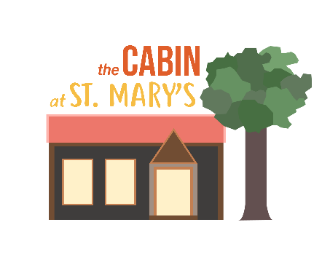
The Cabin at St Mary’s
Appendix 2 – Booking Form for use from 13/04/21
Please complete and return this form to the Bookings Secretary via cabin@stmaryshardwick.org.uk
Name:
Group/organisation:
Address:
Email:
Tel No: Mobile:
Day(s) required
Date of proposed hiring:
Day:
Time required (remember to allow for set-up and pack-down). During Covid-19 times, an extra 30 mins cleaning time is allowed, free of charge, to ensure that extra care is taken in sanitising. See Covid -19 Risk Assessment (Appendix 4).
Clean (free): From To
Activity: From To
Clean (free): From To
If a recurring booking is requested please give details below:
Dates:
Facilities required – Please tick:
Main hall |  | Kitchen for making drinks only |  | Outside area
Meeting room |  | Kitchen for food prep and cooking (extra charge) |  | Exclusive use of all facilities

Please note that the carpark, garden, toilets and kitchen (for making drinks) may be shared by other users of the building and the church. If this is not acceptable, please tick ‘exclusive use of all facilities’ and email the Bookings Secretary to check cabin@stmaryshardwick.org.uk

Type of event – Please tick and give details:
Type |  | Details (including likely numbers attending)
Private (eg birthday party, business meeting, family celebration)

Community group/not for profit
eg toddler group, art group, exercise class where the organiser only takes sufficient money to cover reasonable expenses.

‘For profit’ groups where the organiser/leader earns a living through fees charged

Insurance provided by hirer: Yes/No
Safeguarding policy: Yes/No/Not applicable
Covid risk assessment: Yes/No
TEN for sale of alcohol: Yes/No/Not applicable
Declaration
I certify that I am over 18 years of age and I have read the Terms and Conditions of hire. I accept responsibility for observance of the regulations and agree to pay, on demand, the letting charge incurred.
The person or organisation hiring the facilities:
Electronic Signature:
Date:

